**Numericals: [5+5+10 = 20]**

**Question 1:** We observe an increase in the total delay (time) for those requests that encounter a web cache (a penalty because of the involvement of the cache). Let LD be the average LAN delay, ALD be the access link delay, ID be the Internet delay, and RT be the total response time. Moreover, assume that ACP is the average cache penalty delay. The following values are given LD = 10ms, ALD = 50ms, ID = 100ms, and ACP = X+ ms. Considering the above scenario and given values, answer the following questions:

1. Find the average response time, TR, without use of cache?
2. Find the average response delay (time) when a cache is used and the hit ratio is 80%?

[2.5 + 2.5 = 5]

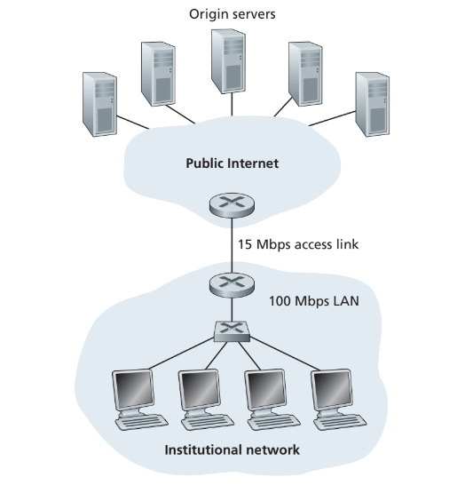

**Question 2:** Consider Figure 2.12, for which there is an institutional network connected to the Internet. Suppose that the average object size is XXXX,000 bits and that the average request rate from the institution’s browsers to the origin servers is 16 requests per second. Also suppose that the amount of time it takes from when the router on the Internet side of the access link forwards an HTTP request until it receives the response is three seconds on average (see Section 2.2.5). Model the total average response time as the sum of the average access delay (that is, the delay from Internet router to institution router) and the average Internet delay. For the average access delay, use Δ/(1 – Δ), where Δ is the average time required to send an object over the access link and is the arrival rate of objects to the access link.

a. Find the total average response time.

b. Now suppose a cache is installed in the institutional LAN. Suppose the miss rate is (X+)/100. Find the total response time.

[2.5 + 2.5 = 5]

**Question 3:** Consider a short, 10m link, over which a sender can transmit at a rate of 150 bits/sec in both directions. Suppose that packets containing data are 100,000 bits long, and packets containing only control (e.g., ACK or handshaking) are 200 bits long. Assume that N parallel connections each get 1/N of the link bandwidth. Now consider the HTTP protocol, and suppose that each downloaded object is 100K bits long, and that the initial downloaded object contains 10 referenced objects from the same sender. Answer the following:

1. Calculate the time it takes to download all the objects via parallel non-persistent HTTP instances.
2. Calculate the time it takes to download all the objects via parallel persistent HTTP
3. Calculate the time it takes to download all the objects via non-parallel persistent HTTP.
4. Would parallel downloads via parallel instances of non-persistent HTTP make sense in this case? Justify your choice.
5. Do you expect significant gains from non-persistent parallel HTTP connections over the non-parallel persistent case? Justify.

[2+2+2+2+2=10]

**Descriptive Questions:**

**Question 4:** Consider the following string of ASCII characters that were captured by Wireshark when the browser sent an HTTP GET message (i.e., this the actual content of an HTTP GET message). Answer the following questions.

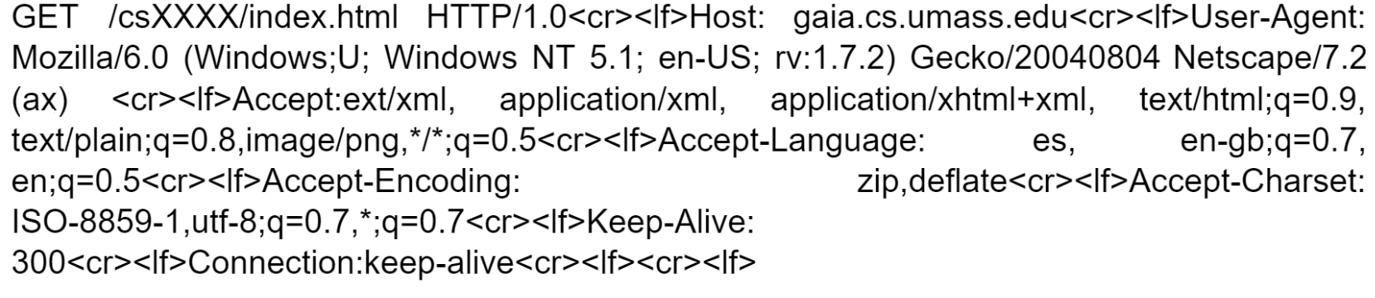

a. What is the URL of the document requested by the browser?

b. What version of HTTP is the browser running?

c. Does the browser request a non-persistent or a persistent connection? If it is persistent then for how long will the connection be open?

d. What is the IP address of the host on which the browser is running?

e. What type of browser initiates this message? Why is the browser type needed in an HTTP request message?

f. What are the language/s acceptable and the acceptable character set/s for response?

g. What should be different in the above header if the user wants the opposite kind of connection (as in if the connection is non-persistent then persistent is needed). You are only needed to write the portion which needs to be changed and what should be changed to.

[1+1+1+2+2+2+1 = 10]

**Question 5:** What is a Conditional Get request in HTTP? How does it reduce unnecessary data transfer? Describe a situation in which Conditional Get proves to be a better choice than GET request.

[1+2+2 = 5]

**Question 6: (Do it on your handwritten assignment and solve a recursive query pattern)** Suppose you would like to create a startup and register its domain name called www.TheBestCompany.com . In order to register a domain name, you will have to go to the DNS registrar to enter Resource Records (RR) in the DNS distributed database. Below is a sketch that you will have to complete to show the connectivity between the end-systems to resolve the IP address of the startup you just initiated. Assume that you have 100,000 web servers and your own name server.

1. You are required to write the two RRs needed to make this whole system work by filling the table below:

|  |  |  |
| --- | --- | --- |
| Name | Value | Type |
|  |  |  |
|  |  |  |

1. Draw the arrows and label each arrow with a sequence number below:

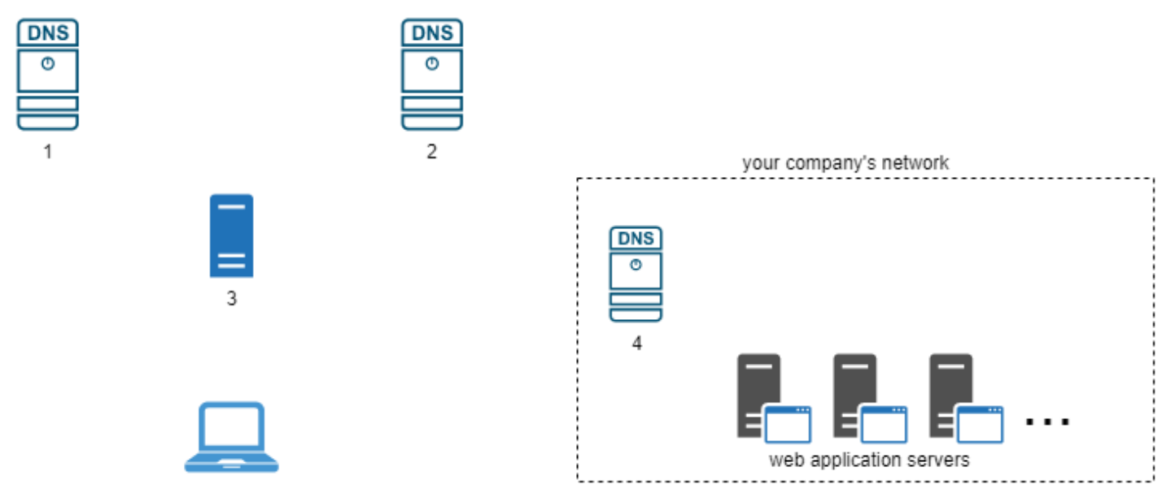

c. End-hosts labelling

1. ___________________________________________

2. ___________________________________________

3. ___________________________________________

4. ___________________________________________

d. In which server will the two RRs be inserted that you filled in the table above?

[2+3+4+1=10]

**Question 7:** What is the format of a resource record? Describe 4 different types of Resource Records, include their formats and explanation of elements in the format tuple.

[1+1+1+1+1 = 5]

**Question 8:**

1. What is frame interleaving? How frame interleaving improves resource loading - discuss this part using a scenario based example to show your understanding.
2. Discuss security concerns associated with cookies. Also, differentiate between persistent and session cookies.

[2+3 = 5]

**Question 9:** Describe differences between SMTP (Simple Transfer Protocol) and IMAP (Internet Message Protocol). Explain how they work together in the context of email communication.

[2+3 = 5]

**Question 10:** Suppose user “XXXX”, with a Web-based e-mail account (such as Gmail or Outlook): sends a message to user “X+”, who accesses his mail from his mail server using POP3. Discuss how the message gets from the host of “XXXX” to the host of “X+”. Be sure to list the series of application-layer protocols that are used to move the message between the two hosts. Furthermore, discuss from a user’s perspective, what is the difference between the download-and-delete mode and the download-and-keep mode in POP3?

[3+2=5]